**Azure DevOps**:

Azure DevOps supports a collaborative culture and set of processes that bring together developers, project managers, and contributors to develop software. It allows organizations to create and improve products at a faster pace than they can with traditional software development approaches.

Login to azure portal and search for Azure devops organizations  
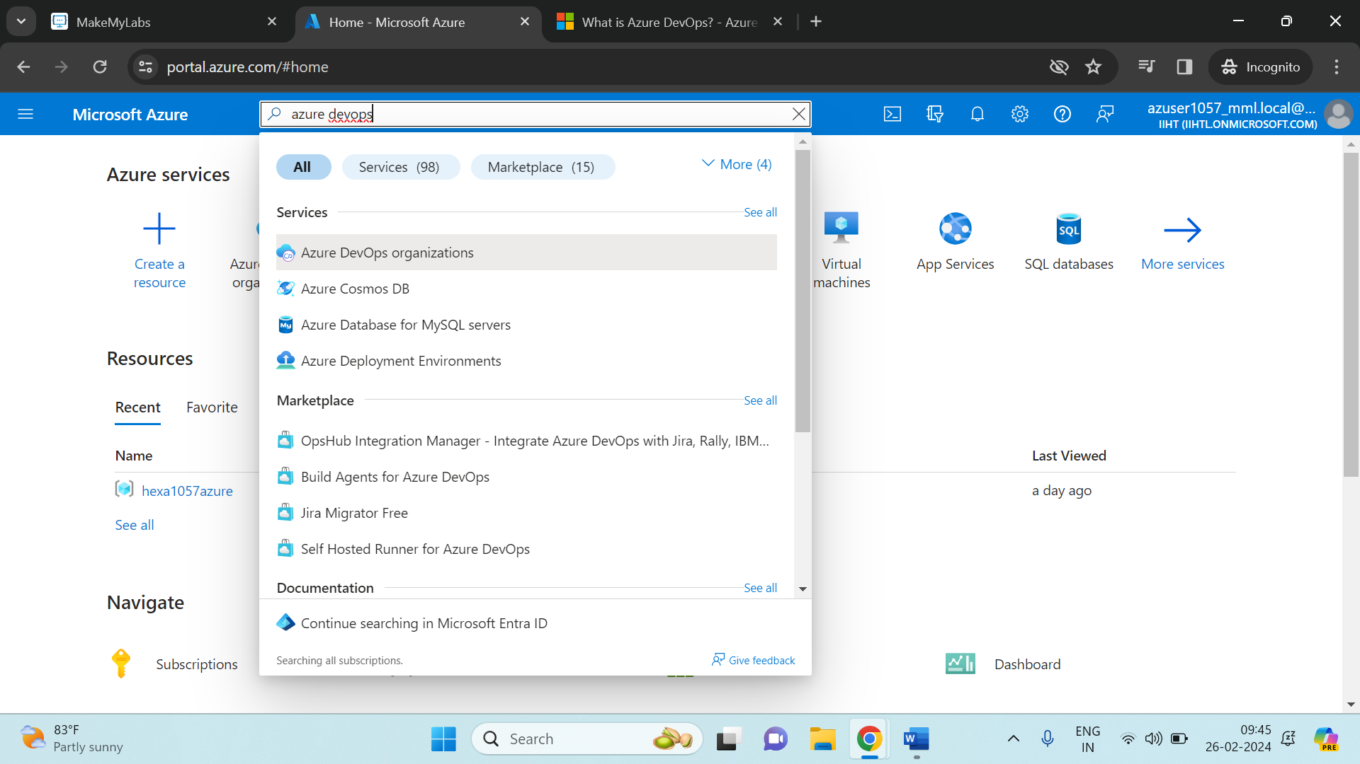

Click on My Azure DevOps Organizations  
  
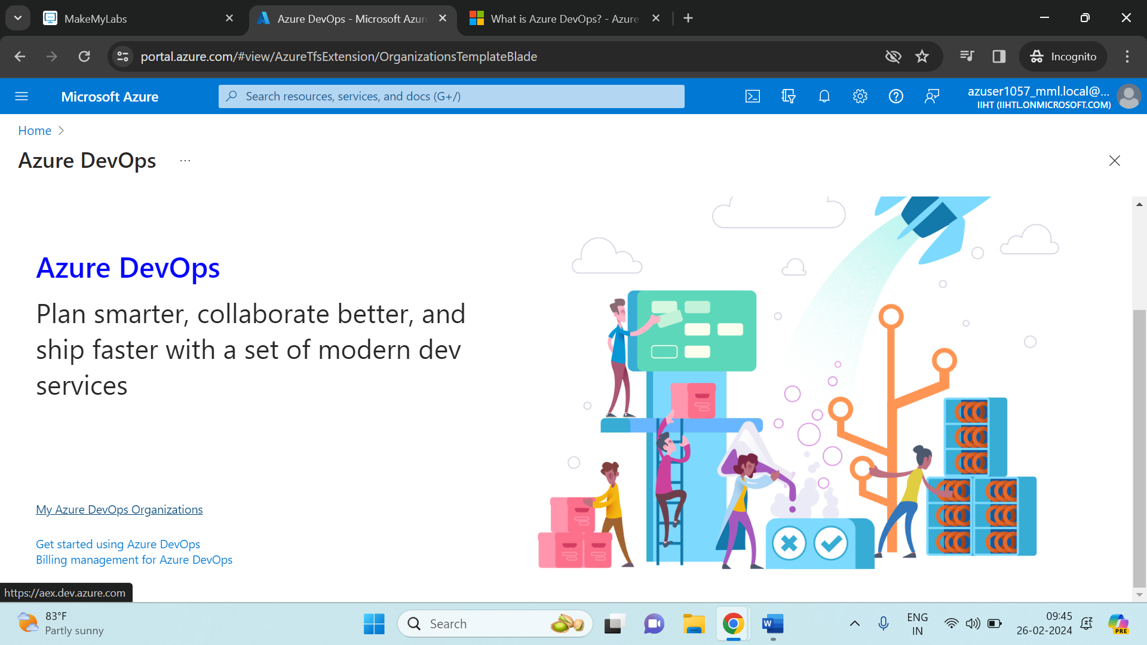

Write your project name and little bit of description about what is your project. Select **Private** only and click on Create Project.

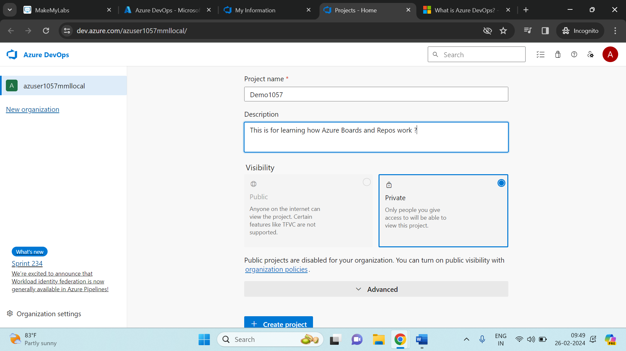

**Boards**:

The interface of Azure Devops will be like given below:  
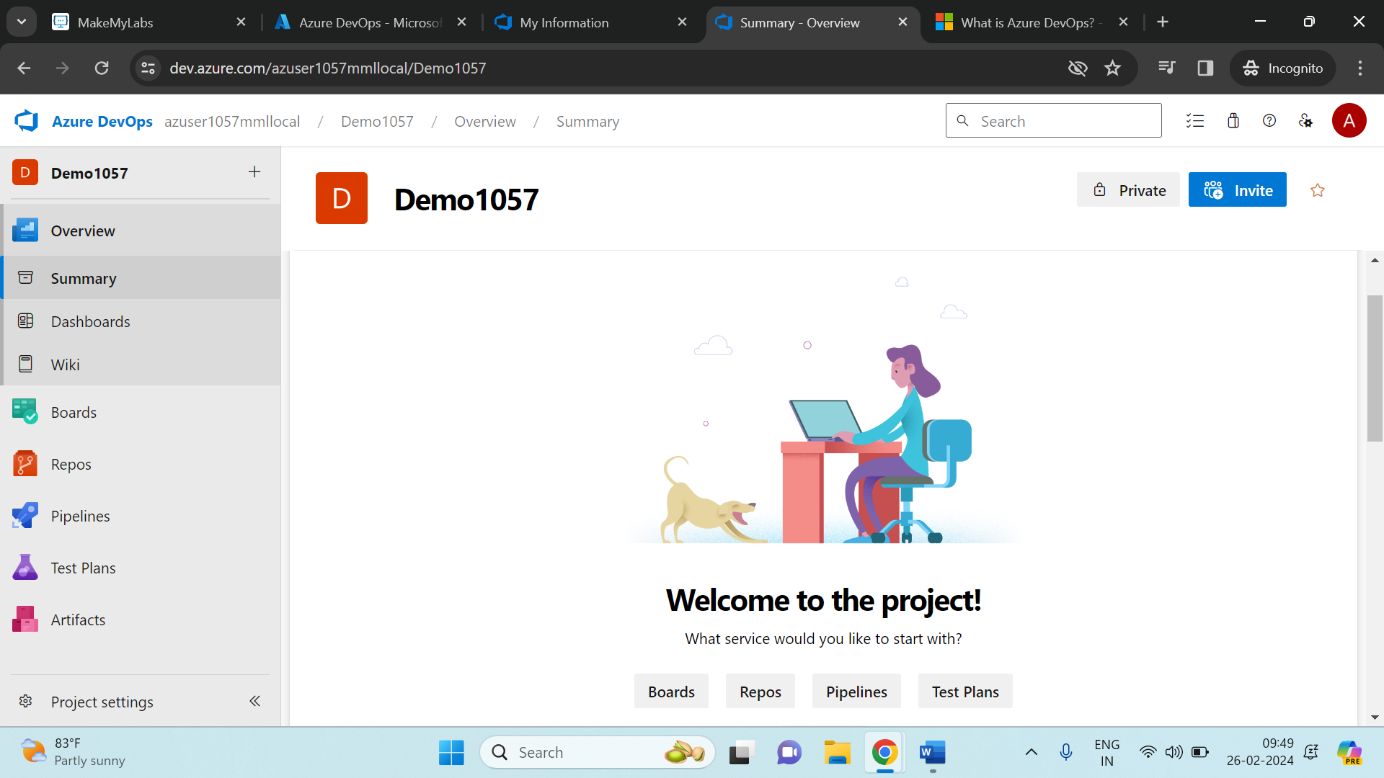

As you can see here on the left side there are 6 main components in the Azure Devops on the left side namely **Overview**, **Boards**, **Repos**, **Pipelines**, **Test Plans** and **Artifacts.** Now in this session we will see how Boards and Repos works.

Click on Boards and select in it ‘Work Items’. In work items select ‘new work item’ and select ‘epic’.

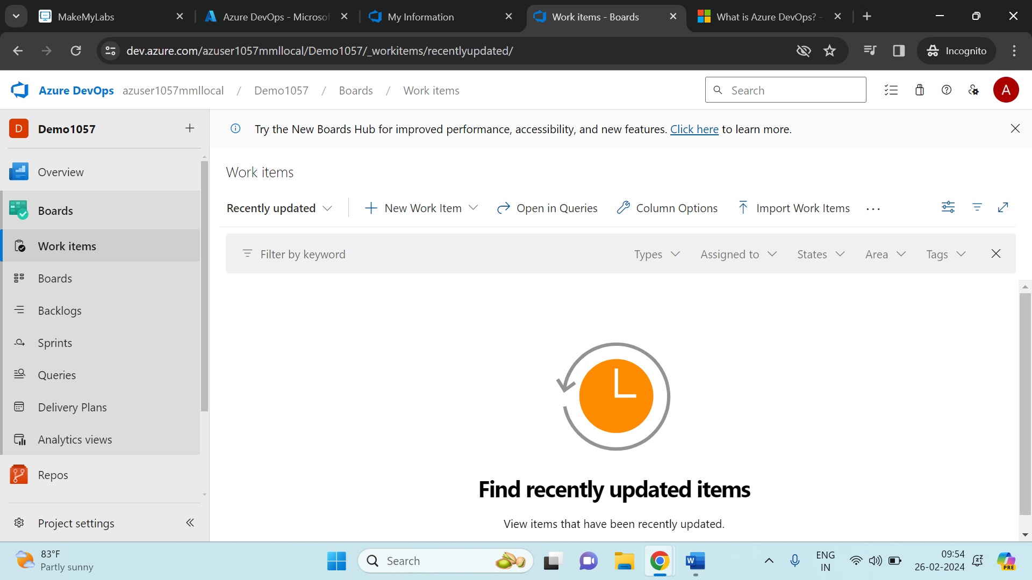

After selecting epic in the New work item, you need to enter a title, write a small description, set the start date and target date, set the Priority, assigned it to someone in a team and save it.

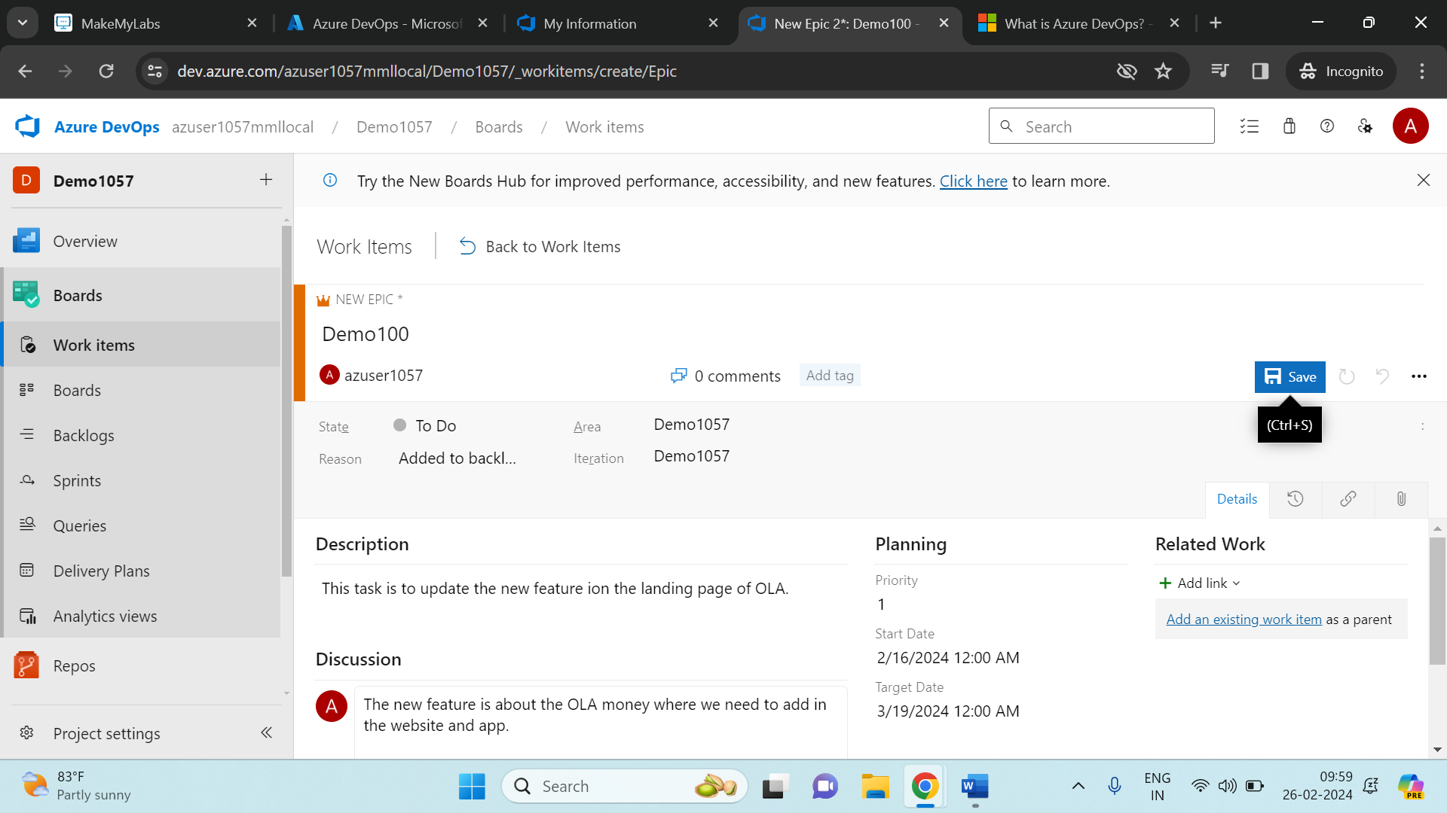

Similarly create another epic as shown below.

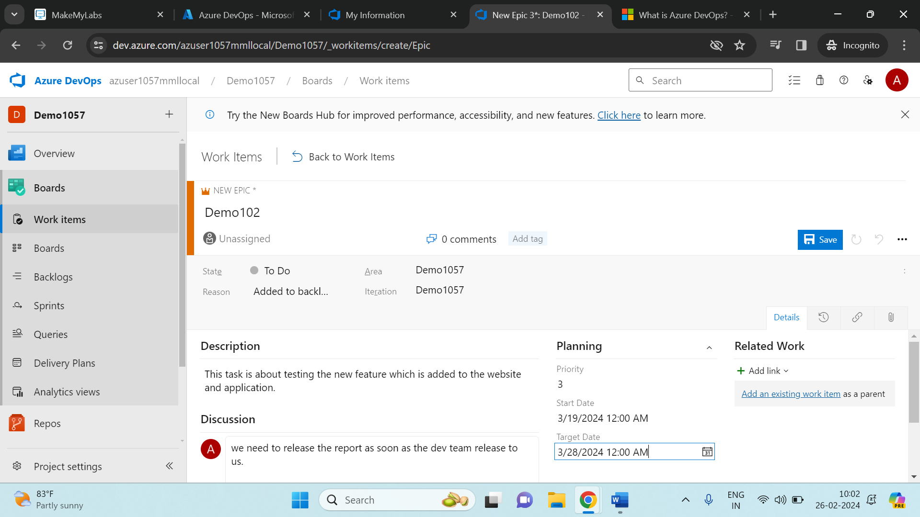

Create a couple of issue and task 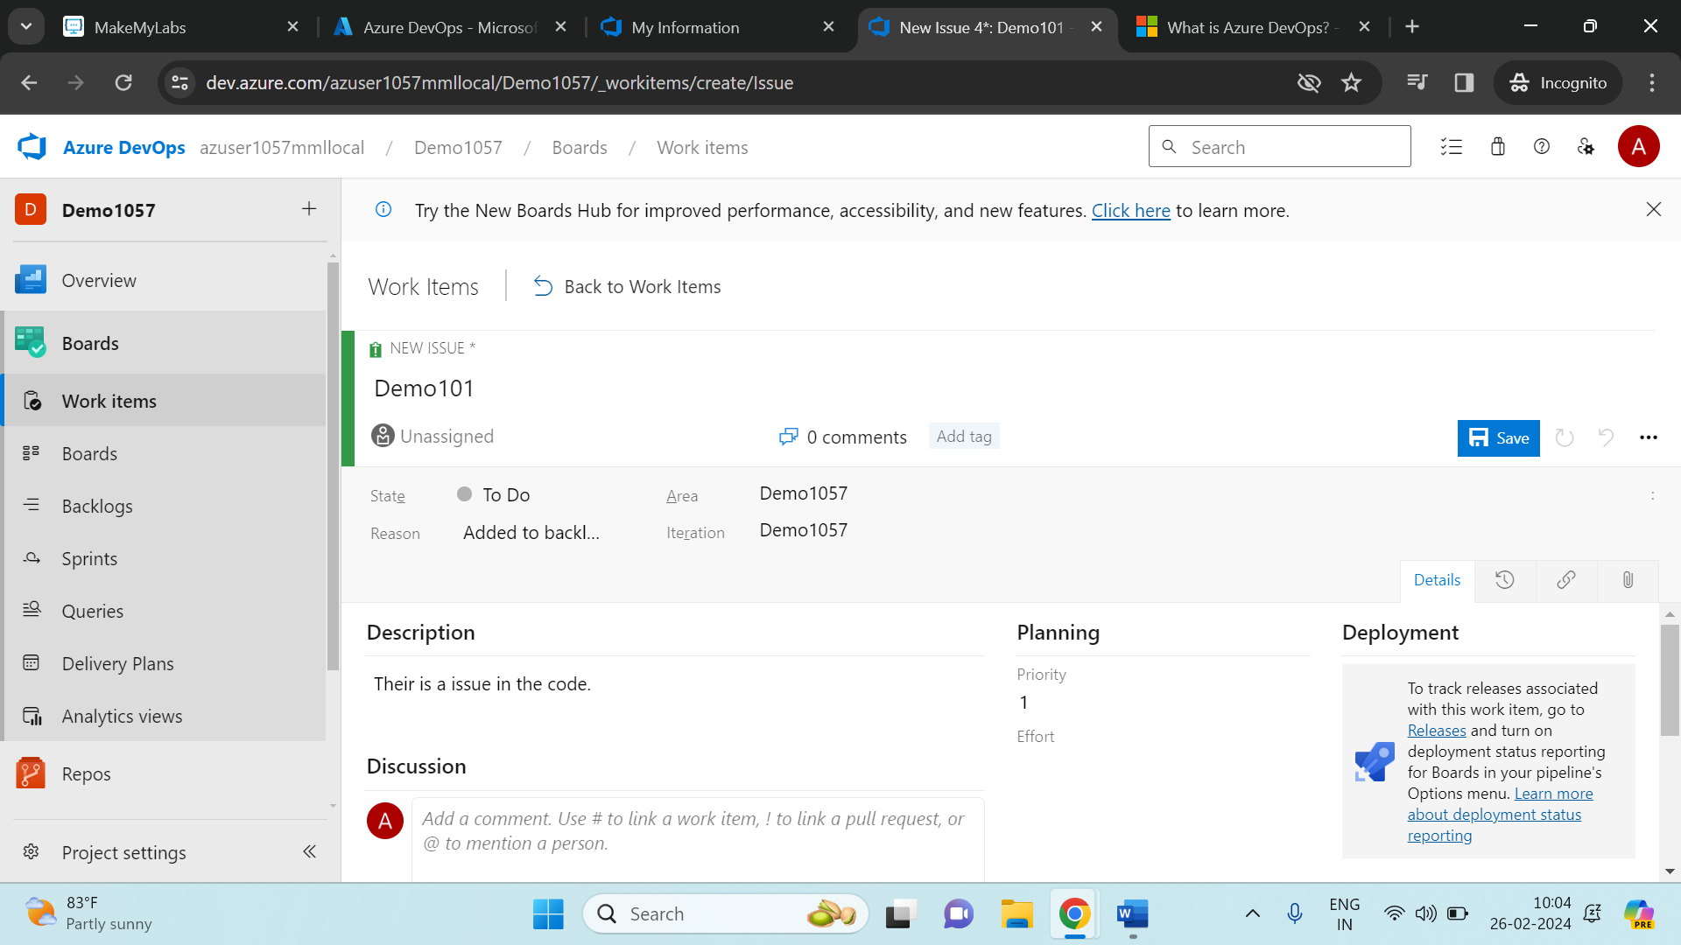

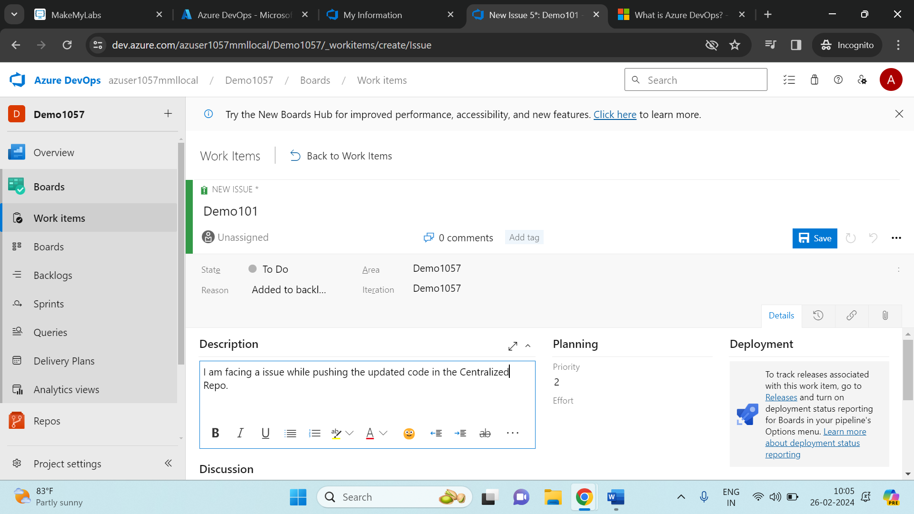

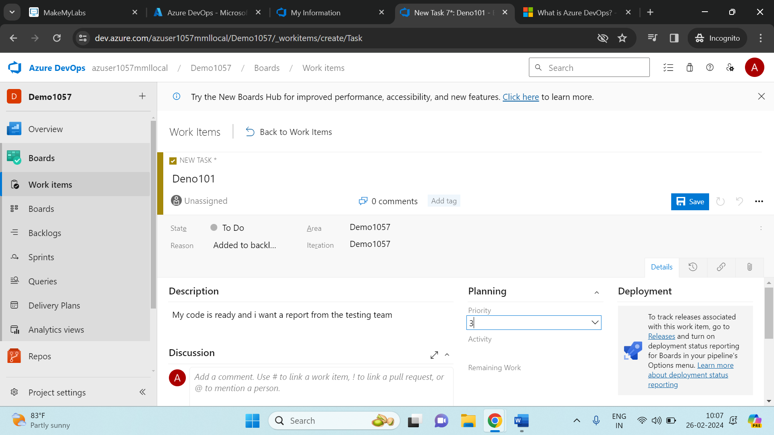

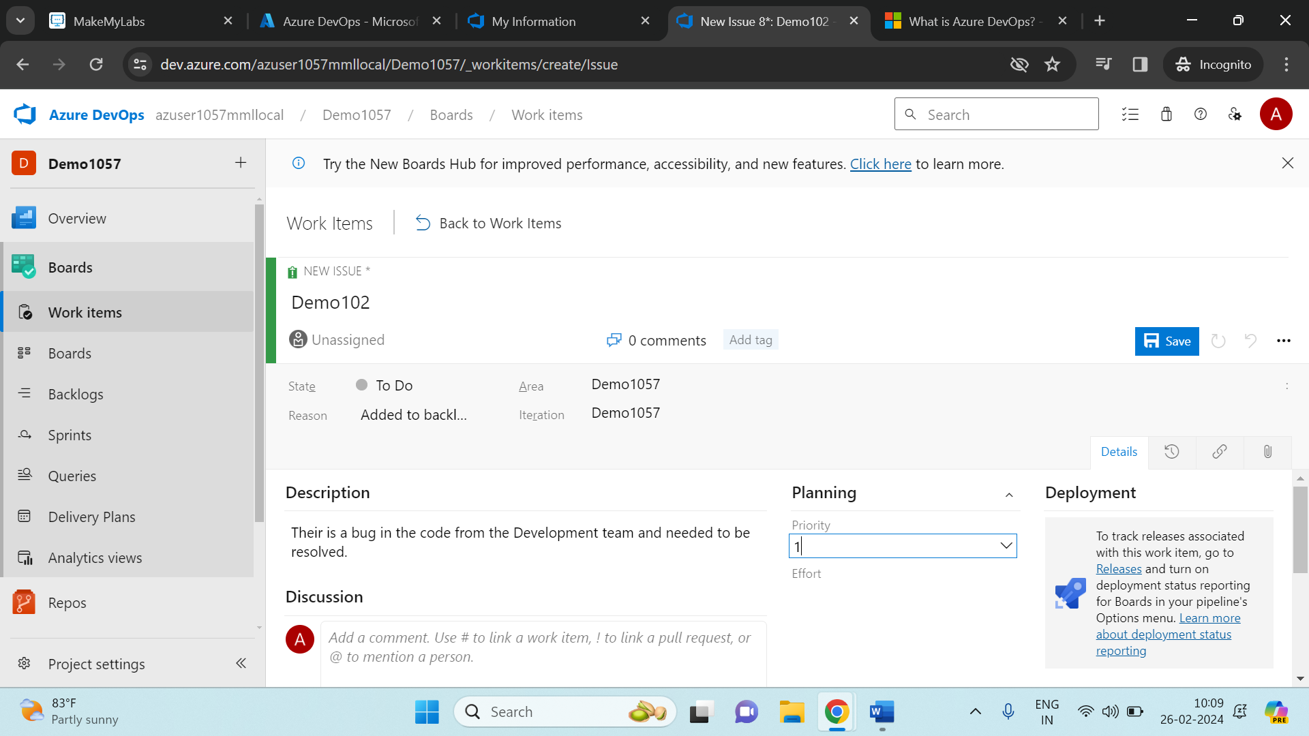

In the Boards, you can see what are all the issues written in the Work Items will be shown in the Boards.

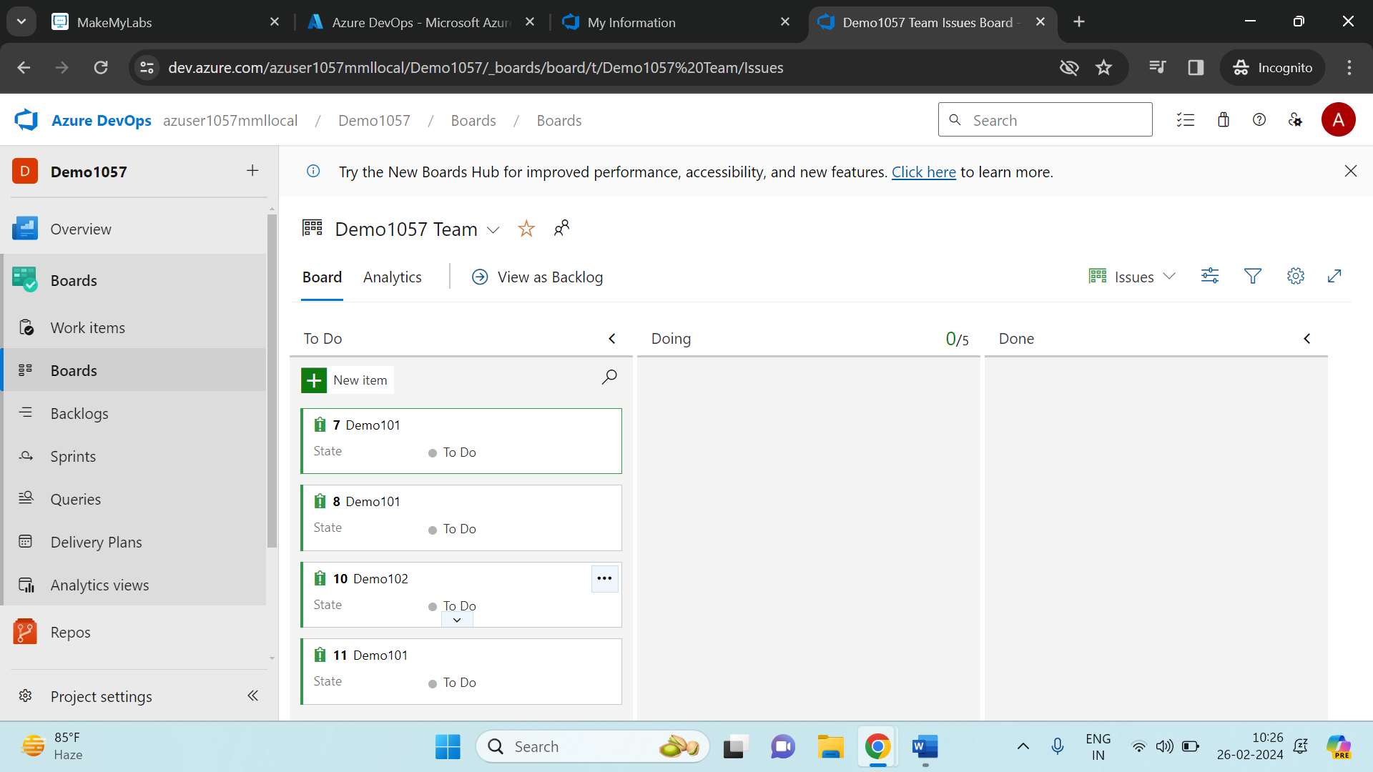

In Boards, we can see 3 Columns which shows us the status of the issue. Once you write down the issue and yet to start it will be in **To Do** stateand when you start it will be in **Doing** state and once the issue is completed it will be moved to **Done** state.

Some issues which cannot be resolved and has less priority will be send to backlog, where it can be discussed in the sprint session.

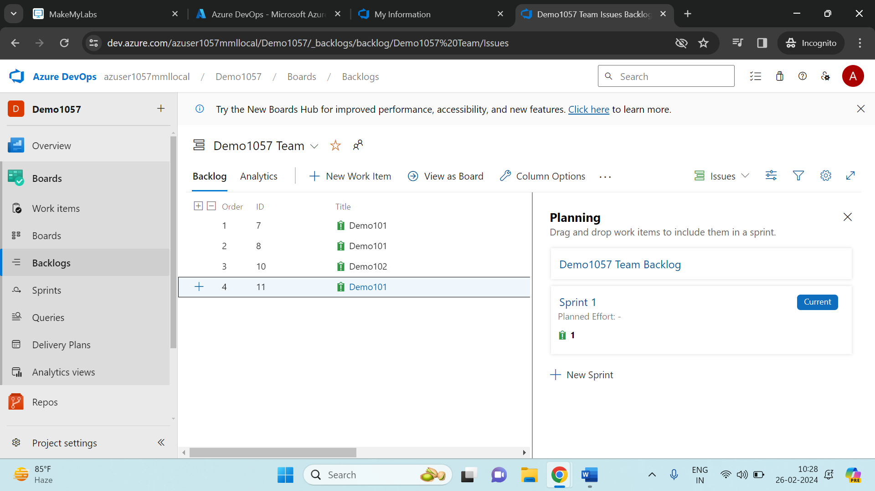

In the sprints session, we can see what all are the backlogs that we need to be discussed in the meeting and get to be resolved.

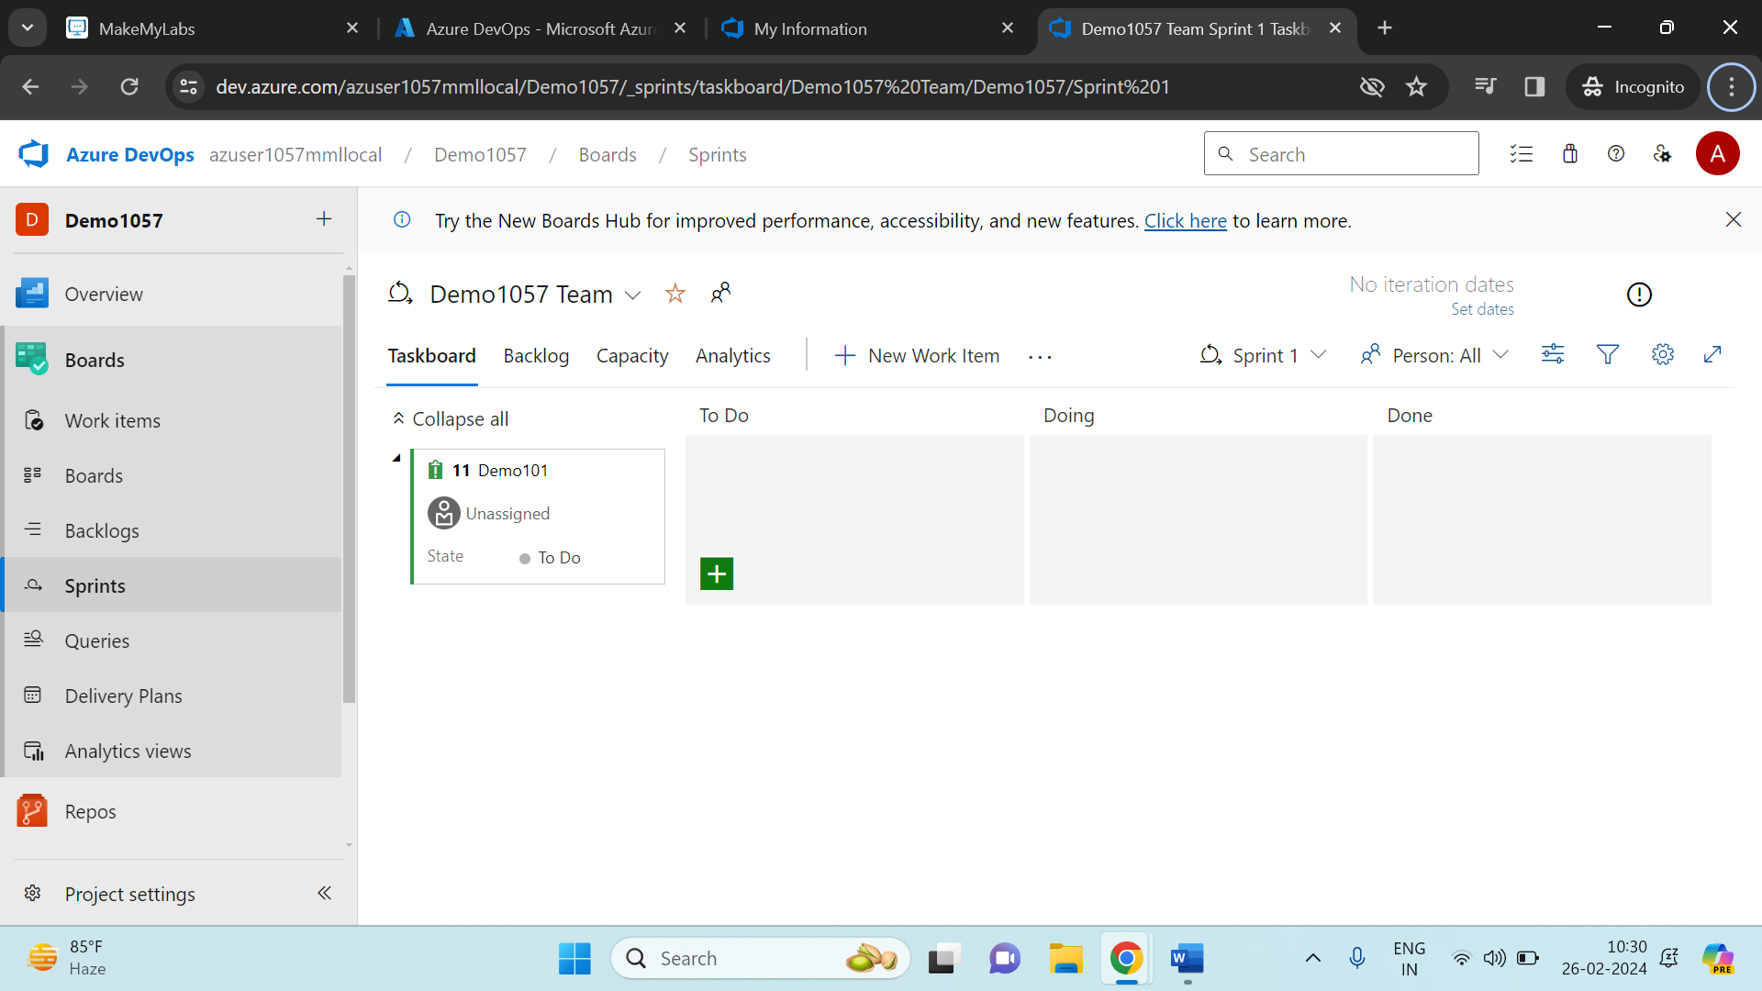

**Repos**:

The Repo interface will be as shown below.

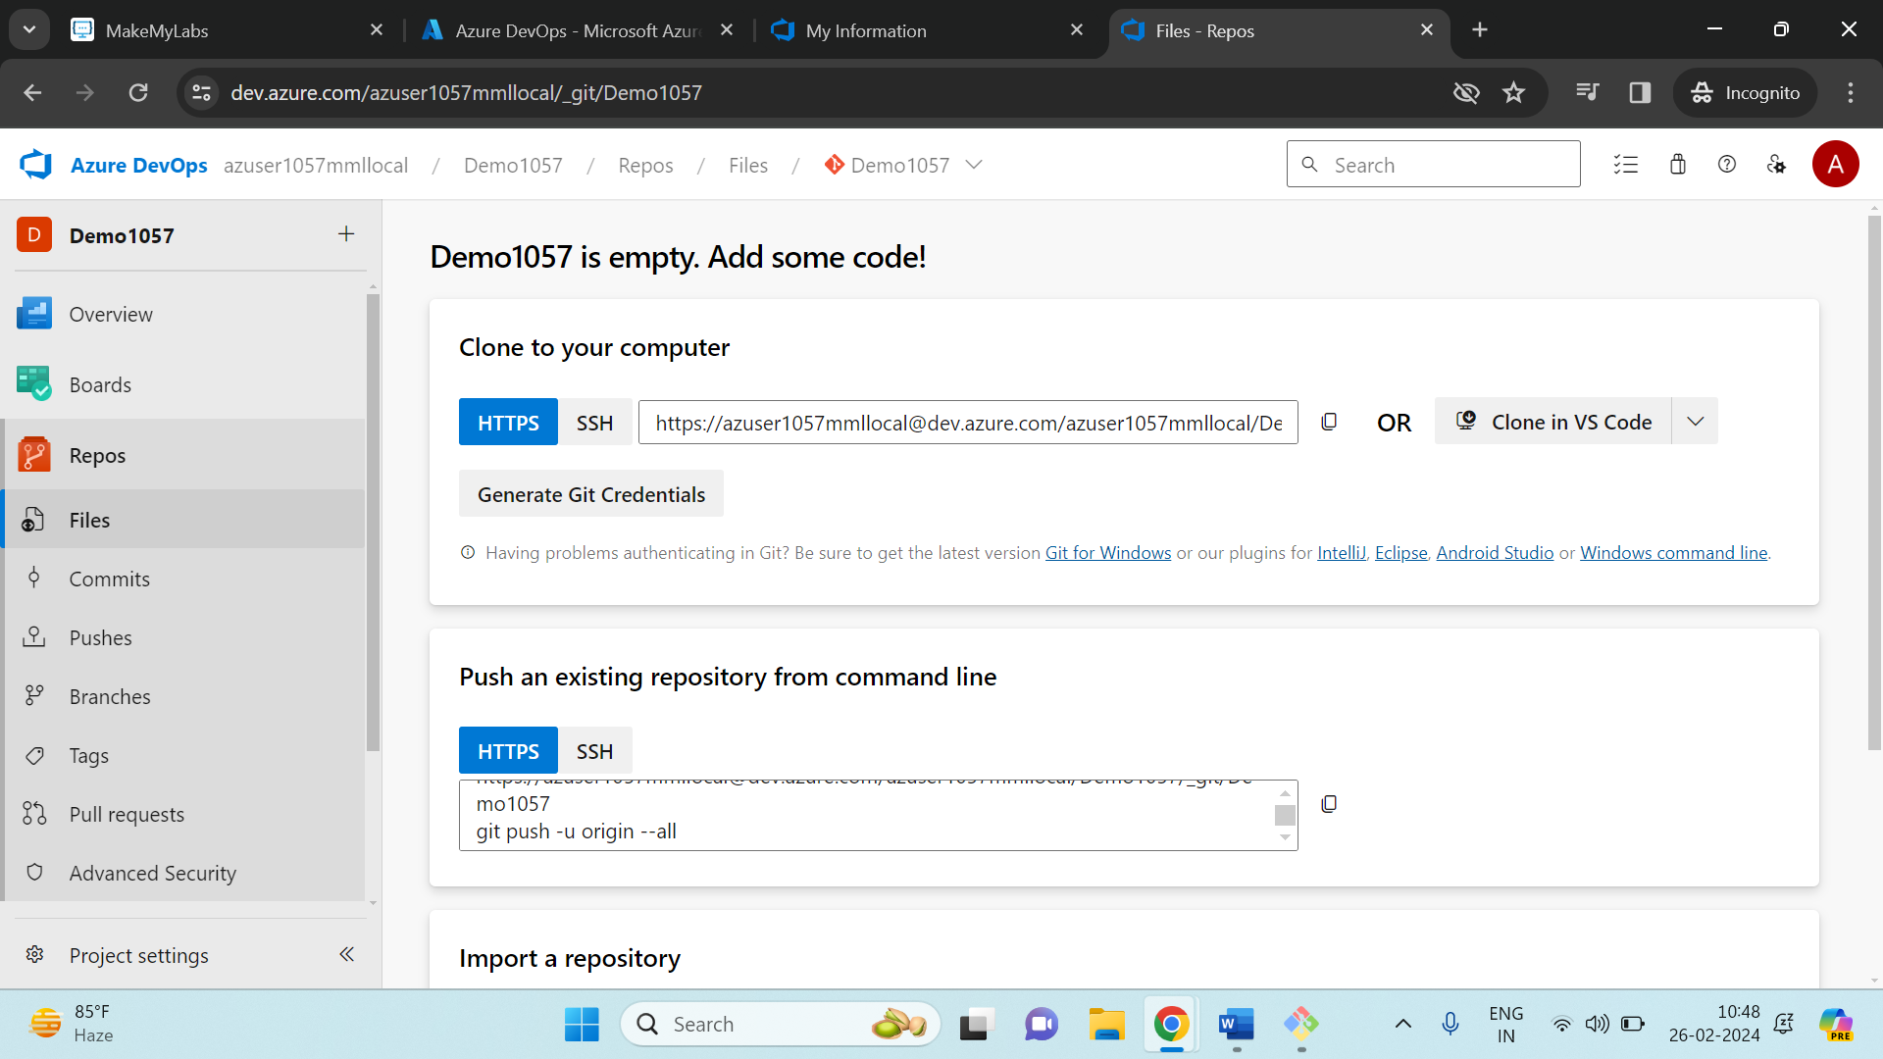

We need to connect the repo with the local repository using git bash. And the connection is to be established is as follows:

